Payment of 25/26 main liability insurance premium – Premium payable to Council insurance brokers, Marsh Ltd. Policy runs from 1st November 2025 to 31st October 2026

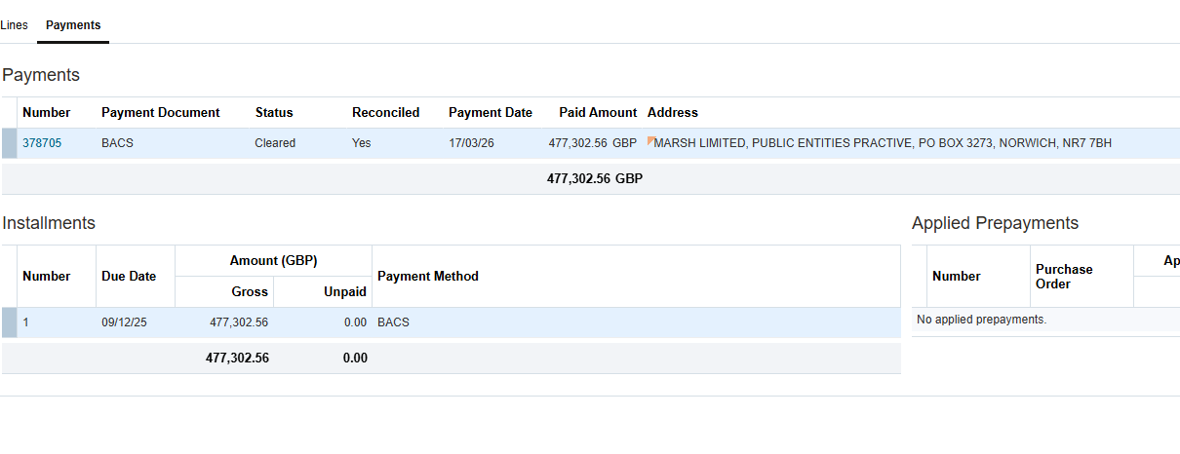

Payment of25/26 excess layer liability insurance premium – Premium payable to Council insurance brokers, Marsh Ltd. Policy runs from 1st November 2025 to 31st October 2026

